Flipper Zero NFC Testing Guide
Theory and Practical NFC Workflow

Introduction
This guide explains NFC on the Flipper Zero in simple language and then walks through practical testing in a way that is easy for beginners to follow. It starts with the theory, shows what to expect on screen, and still includes advanced topics such as MIFARE Classic key recovery, manual card creation, and writing compatible NTAG tags.
The goal is to help a new user understand not just which menu to open, but also why each step matters. For example, if you read a transport-style card and the Flipper shows only a UID, that usually means the card is either unsupported for full parsing or protected by a protocol that cannot be fully read like a simple tag.
NFC (Near Field Communication)

NFC
NFC stands for Near Field Communication. It is a short-range wireless technology that usually works at 13.56 MHz and lets a reader and a card or tag exchange data when they are brought very close together, usually just a few centimeters apart.
A simple example is an NFC sticker used to open a website when tapped by a phone. A more structured example is an office access card, where the card may contain a UID, memory blocks or sectors, and in some cases security keys or application data.
Flipper Zero has a built-in 13.56 MHz NFC module and can read, save, and emulate many NFC card types. Depending on the card family, memory may be arranged in pages, sectors, blocks, or applications, which is why one card may look easy to read while another may need keys, passwords, or only expose limited information.
Think of NFC card types like different file formats. Two cards may both be “NFC cards,” but one may behave like a simple text note, while another behaves more like a locked database that only opens with the right keys.
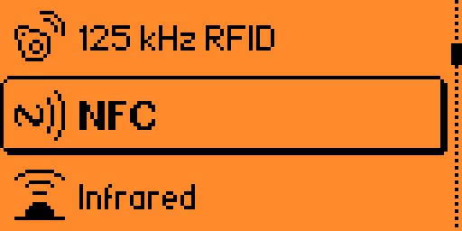
Figure 1.1 — Main menu with NFC highlighted, alongside 125 kHz RFID and Infrared.

Where to place the card
On Flipper Zero, the NFC antenna is used from the back of the device. When reading, emulating, or writing, place the card or tag flat against the back and move it slowly around the upper rear area until the device detects it.
Beginners often miss this because they try the front screen side first. If a card is not detected, one of the first things to check is whether the card is touching the correct side of the Flipper.

Common NFC types you may encounter
You do not need to memorize every protocol before testing, but it helps to know the common families the Flipper Zero can work with and what each one is usually used for.
- MIFARE Classic: often seen in older access cards and lab badges. Flipper can read, save, and emulate these cards, but full reading depends on finding the correct sector keys.
- MIFARE Ultralight and NTAG: common in simple tags, digital business cards, and tap-to-open links. These are usually easier for beginners because data is often stored in pages and many tags are readable without deep authentication.
- MIFARE DESFire: used in more secure systems such as some enterprise or transport environments. Flipper can read certain visible information and save available data, but encrypted applications are not fully emulated.
- Type V tags such as iCODE SLIX: often used in specialized inventory or tagging scenarios. These use block-based memory rather than the Classic sector model.
- FeliCa Lite-S and some Type B cards: supported to varying degrees, with some cards allowing read and save, and others exposing only limited identifiers.
A practical example is this: if you tap a blank NTAG213 sticker, you may read the pages and later write compatible data to another NTAG213. If you tap a protected MIFARE Classic office card, Flipper may first need to discover its keys before all sectors can be read.

Special case: HID / PicoPass cards
Some access cards (commonly HID iCLASS / PicoPass cards) will not show up properly when scanned through the standard NFC → Read menu. The Flipper Zero may fail to detect the card at all, or only report a generic/blank result, because these cards use HID's proprietary PicoPass protocol rather than a standard MIFARE/NTAG format that the built-in NFC app parses.
To read this type of card, the standard NFC app is not enough. Instead, install the dedicated PicoPass app from the Flipper application catalog (through the Flipper mobile app's “Apps”/NFC category, or via qFlipper / the Flipper Lab app store on a computer), then open that PicoPass app on the device and scan the card from there instead of using NFC → Read.
- Search for “PicoPass” in the app catalog and install it onto the Flipper Zero.
- Open Apps → NFC → PicoPass on the Flipper Zero (instead of the built-in NFC → Read).
- Hold the HID card against the back of the Flipper Zero the same way as any other NFC card, and the PicoPass app will read it.

The normal beginner workflow
For most practical sessions, follow the same pattern every time: read the card, inspect what was captured, save it with a clear name, and only then try emulation or other advanced actions. This keeps your tests organized and makes troubleshooting much easier.
- Read first, so you know what kind of card you are working with.
- Save second, so you can return to the captured card later without scanning again.
- Emulate only after you understand what was actually captured.
- Try writing only when the card type supports it and the destination tag is compatible.

Reading an NFC card
Open Main Menu, go to NFC, and choose Read. The Flipper will ask you to hold the card near the back of the device, and the detection process is automatic, so you do not usually need to choose the protocol manually for everyday cards.
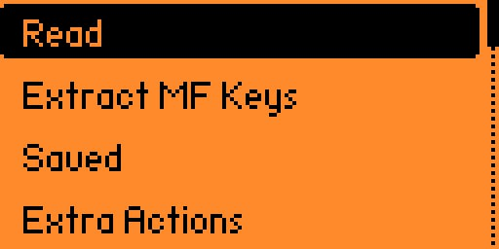
Figure 1.2 — The NFC menu (Read, Extract MF Keys, Saved, Extra Actions), with Read highlighted/selected.
Hold the physical card flat against the back of the Flipper Zero and keep both still while it scans.

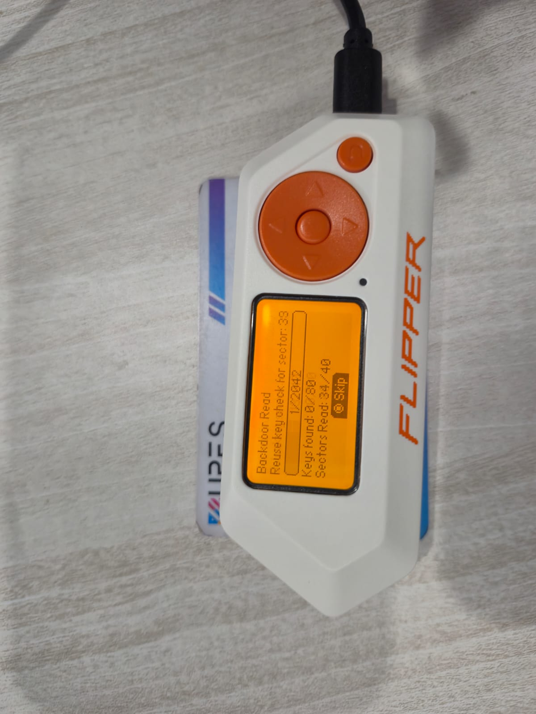
Figure 1.4 — The Flipper Zero performing a “Backdoor Read”, checking security keys sector by sector. This is the same automatic key-checking process referenced later in “Understanding MIFARE Classic and keys”.
When the read succeeds, look at the result carefully. A beginner should pay attention to the card type, UID, and whether the Flipper was able to access memory or only basic identifiers.
Example: if the screen shows something like NTAG213 and displays page data, that is a good sign the tag is simple and readable. If it shows MIFARE Classic with only some sectors available, that means more work may be needed to recover the missing keys.
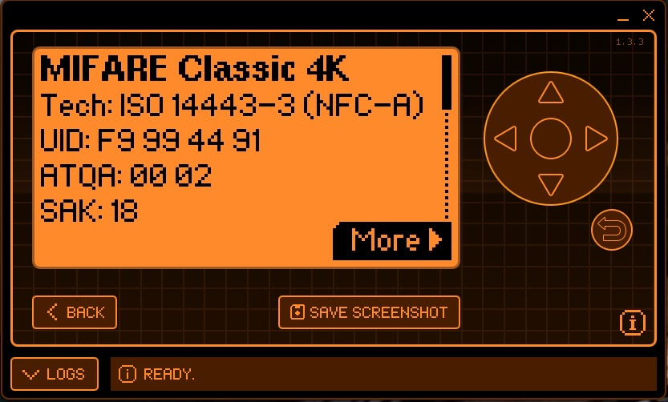
Figure 1.5 — Successful read result: MIFARE Classic 4K, with technology, UID, ATQA, and SAK fields shown.

Saving what you read
After a successful read, open the More menu and choose Save. Give the card a name that makes sense later, such as Test_NTAG213_Blue or Lab_Badge_MFC_01, instead of vague names like card1 or newtag.
This is important in practical lab work because once you collect several tags, good naming helps you track which file came from which test scenario. Saved cards appear in NFC > Saved and can be reopened for emulation or further actions.
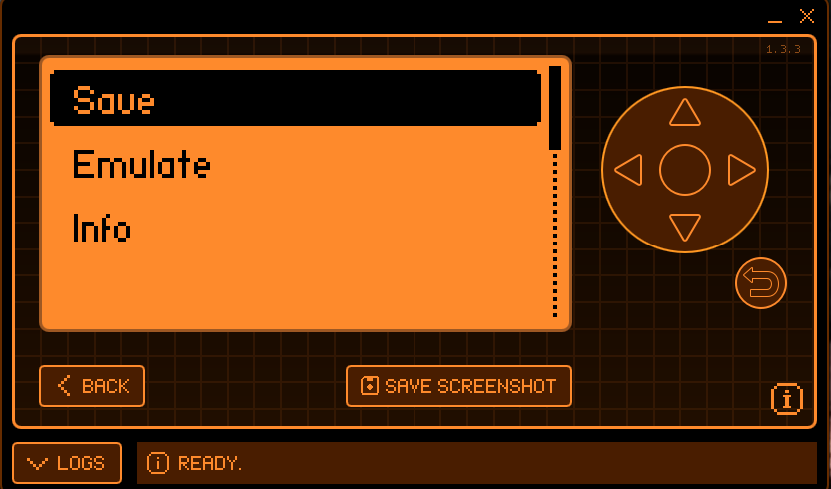
Figure 1.6 — The Save / Emulate / Info action menu shown after a read. Choose Save here.

Emulating a saved NFC card
Emulation means the Flipper Zero pretends to be the card you saved. To do this, open NFC > Saved, select the saved card, choose Emulate, and hold the back of the Flipper near the reader just like you would present the original card.
A beginner-friendly way to understand this is to think of the saved file as a profile. During emulation, the Flipper loads that profile and answers the reader as though it were the original card, but only within the limits of what the protocol and captured data allow.
For example, NTAG tags often emulate quite smoothly. By contrast, more secure cards may expose only limited data, so the emulation may not behave like the original card in a real protected system.
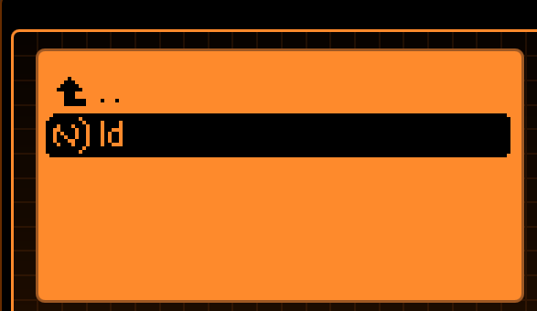
Figure 1.7 — The saved card appears as a file inside the NFC folder.
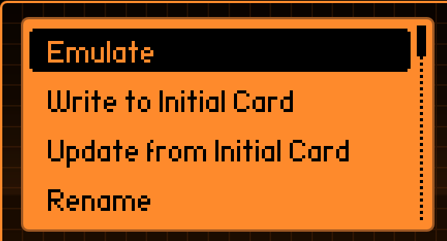
Figure 1.8 — Saved card options, with Emulate visible alongside Write to Initial Card, Update from Initial Card, and Rename.
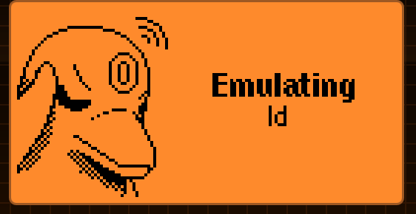
Figure 1.9 — Emulation active on the Flipper Zero.
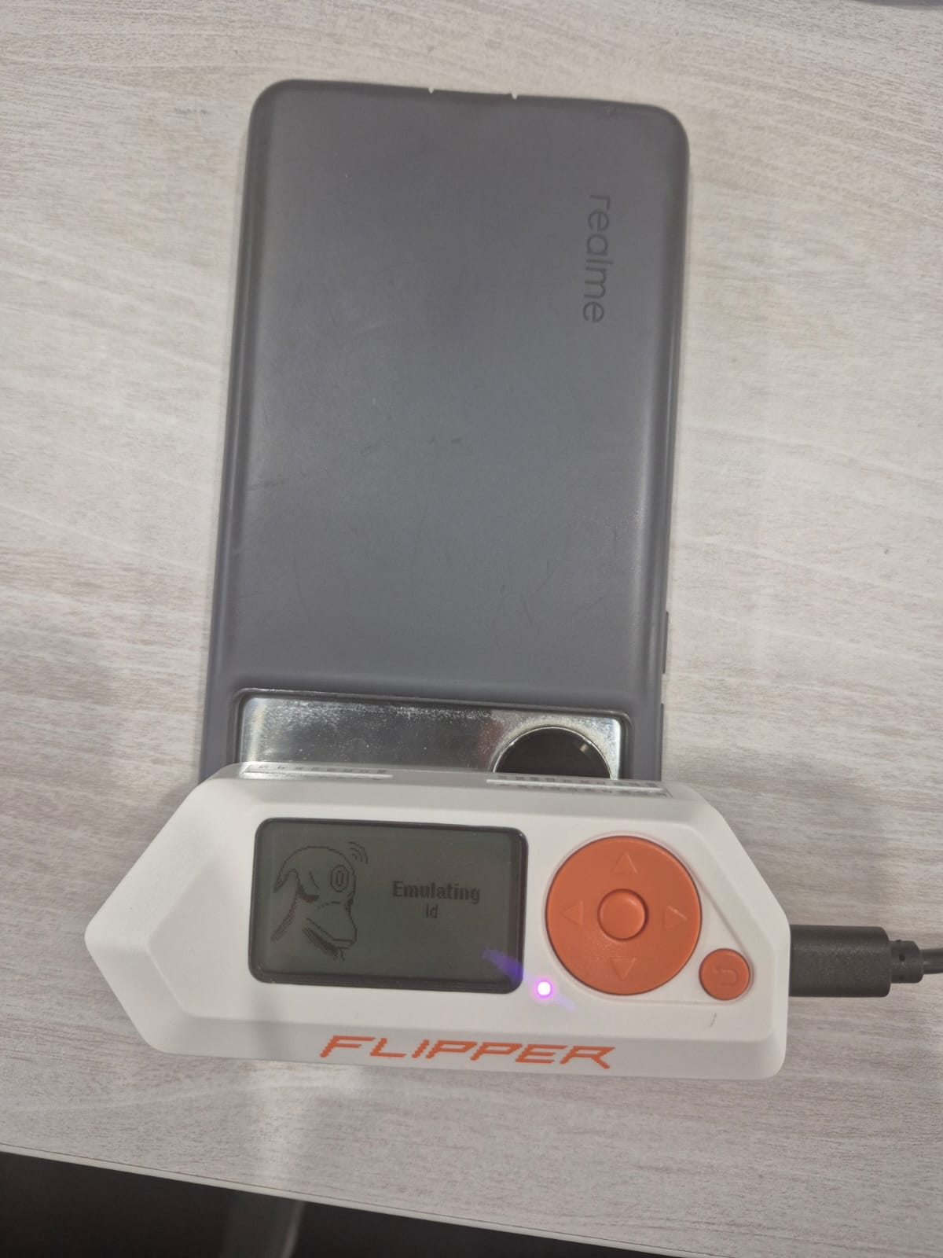
Figure 1.10 — Holding the emulating Flipper Zero against a phone's NFC reading area.
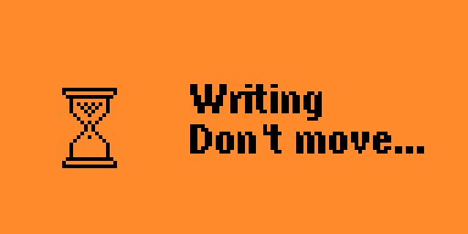
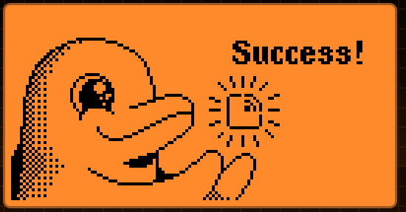
Figure 1.11 — “Success!” confirms the emulated card was accepted by the reader.
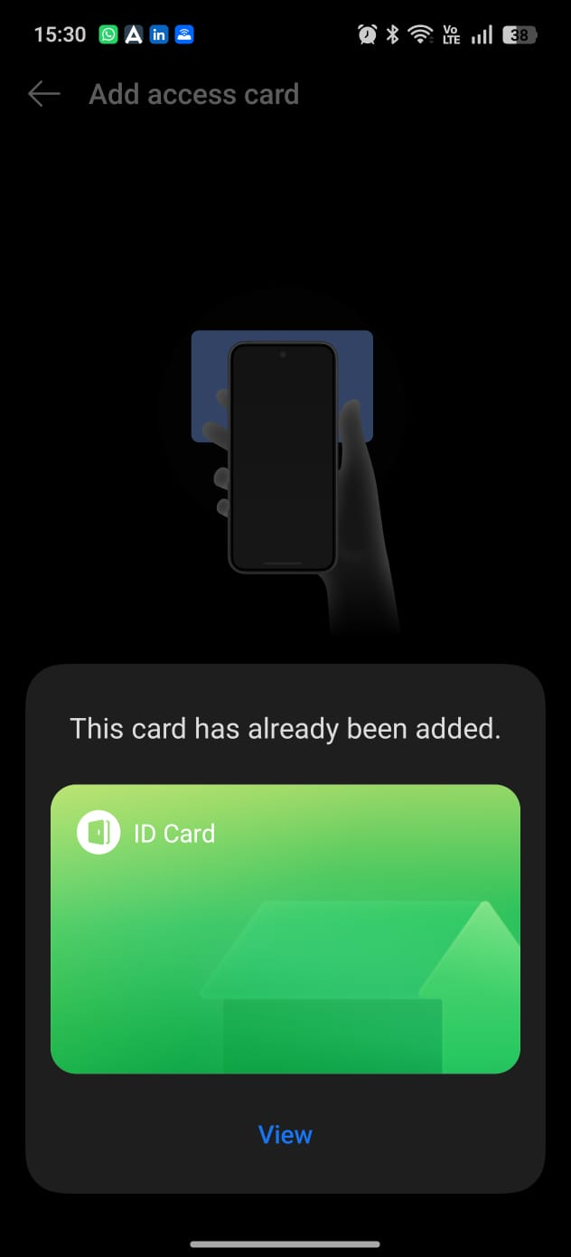
Figure 1.12 — A phone's “Add access card” screen reporting the card has already been added, confirming the emulated card matched the original.

